SIMATS ENGINEERING (SAVEETHA SCHOOL OF ENGINEERING)
Department of Computer Science and Engineering
CO3 ASSESSMENT TOOL 1 – Git & Docker Technical Assignment

Course Code: | CSA10 | Course Title: | Software Engineering
CO Assessed: | CO3 | Assessment: | Assessment Tool 1 – Git & Docker Technical Assignment
Weightage: | 20% | Total Marks: | 25
CO3 Statement: | Build full-stack applications with an emphasis on containerization, version control, and collaborative development
Student Name: | Surya Krishna Teja Yandra | Reg. No.: | 192425065
Date: | 13-08-2026 | Duration: | 60 minutes

Code of Conduct
I Surya Krishna Teja Yandra/192425065 (Name / Reg No) certify that this submission is my original work and that I have adhered to the guidelines specified for this assessment. I understand that any violation of academic integrity rules will result in disciplinary action.
Signature of the Student: _________________________
Annexure A – Git & Docker Technical Assignment
Instructions to Students:
Each student has been assigned an individual problem statement. Based on the assigned problem statement, prepare a Git & Docker Technical Assignment by applying version control and containerization concepts. Your report should include appropriate diagrams, screenshots, commands, and explanations wherever applicable.

Assignment Questions
- Problem Analysis
  - Explain the assigned problem statement and identify the project objectives, functional requirements, and expected outcomes.
- Project Structure Design
  - Design and explain the folder structure of your project repository.
  - Justify the purpose of each major folder and file included in the repository.
- Git Repository Initialization
  - Create a Git repository for the project.
  - Explain the steps involved in repository initialization and describe the purpose of the essential Git files.
- Git Branching Strategy
  - Design a suitable branching strategy (e.g., Main, Development, Feature, Release, Hotfix).
  - Justify why the selected branching model is appropriate for the assigned project.
- Version Control Workflow
  - Demonstrate the Git workflow by performing meaningful commits, branch creation, merging, conflict resolution (if applicable), and repository synchronization.
  - Explain the purpose of each Git operation performed.
- Commit History Analysis
  - Present the commit history of the project.
  - Explain how commit messages follow good version control practices and contribute to project maintenance.
- Docker Environment Design
  - Explain why Docker is suitable for the assigned project.
  - Identify the application components that require containerization.
- Dockerfile Development
  - Design and explain the Dockerfile required to containerize the application.
  - Describe the purpose of each instruction used in the Dockerfile.
- Docker Compose Design
  - Develop a Docker Compose configuration for the project.
  - Explain the services, networking, volumes, environment variables, and dependencies used.
- Container Deployment and Testing
  - Demonstrate the execution of the application using Docker containers.
  - Explain the testing procedure and provide evidence that the application runs successfully.
- Benefits of Git and Docker
  - Discuss how Git and Docker improve collaboration, version management, portability, deployment, scalability, and maintainability for your assigned project.
- Challenges and Improvements
  - Identify the challenges encountered during implementation.
  - Suggest possible improvements and future enhancements for the Git workflow and Docker deployment.

Expected Deliverables
- Technical report (10 pages)
- Git repository with complete commit history
- Source code of the assigned project
- Dockerfile
- Docker Compose file (docker-compose.yml)
- Screenshots of Git operations and Docker execution
- Architecture and workflow diagrams

Rubrics for Calculation
Evaluation Criteria | Excellent (4 Marks) | Good (3 Marks) | Satisfactory (2 Marks) | Needs Improvement (1 Mark)
Problem Analysis & Project Design(20%) | Clearly explains the problem statement, objectives, requirements, expected outcomes, and well-organized project structure with proper justification. | Good analysis and project structure with minor omissions. | Basic analysis and repository structure with limited justification. | Incomplete or unclear analysis and project organization.
Git Repository & Branching Strategy(20%) | Repository initialized correctly with appropriate branching strategy, clear workflow, and proper repository organization. | Repository and branching strategy are mostly correct. | Basic Git setup with limited branching implementation. | Incorrect or incomplete Git repository and branching strategy.
Version Control Workflow & Commit History(10%) | Demonstrates meaningful commits, branching, merging, synchronization, conflict resolution, and professional commit messages with clear history. | Most Git operations demonstrated correctly with good commit history. | Limited Git workflow and commit practices. | Poor workflow and inadequate commit history.
Docker Implementation(20%) | Well-designed Docker environment, Dockerfile, and Docker Compose configuration with clear explanation of services, networking, volumes, and dependencies. | Functional Docker implementation with minor issues. | Basic Docker implementation with limited explanation. | Incomplete or incorrect Docker implementation.
Deployment, Testing & Results(15%) | Application successfully deployed and tested with appropriate screenshots and evidence of successful execution. | Deployment completed with minor issues. | Partial deployment and testing demonstrated. | Deployment unsuccessful or insufficient evidence.
Documentation, Challenges & Future Enhancements(15%) | Professional report (10–15 pages) with diagrams, screenshots, references, discussion of benefits, challenges, and future improvements. | Good documentation with minor omissions. | Basic documentation with limited discussion. | Poor documentation and insufficient analysis.

Criteria | Mark
System Requirement Analysis (30%) | /5
Selection of Software Architecture (25%) | /5
Architecture Diagram and Component Design (20%) | /5
Component Interaction and Quality Attribute Analysis (15%) | /5
Architectural Justification and Technical Presentation (10%) | /5
TOTAL | /25

AI-Driven Smart Disaster Relief Resource Allocation and Volunteer Coordination Platform

1. Problem Analysis
Problem Statement
Disaster relief operations often face delays, resource shortages, duplication, and poor volunteer coordination. The proposed AI platform centrally manages resources and volunteers and uses AI to prioritize relief distribution and optimize routes.
Objectives
- Manage relief resources digitally.
- Coordinate volunteers efficiently.
- Prioritize affected areas using AI.
- Monitor resources in real time.
- Optimize transportation routes.
- Provide emergency dashboards.
- Improve agency coordination.
Functional Requirements
- User registration and login.
- Disaster and resource management.
- Volunteer registration and assignment.
- AI-based resource allocation.
- Route optimization.
- Real-time dashboard and alerts.
Expected Outcomes
- Faster relief distribution.
- Better resource utilization.
- Improved volunteer coordination.
- Reduced response time.
- Better emergency decision-making.

2. Project Structure
disaster-relief/
├── frontend/
├── backend/
├── database/
├── tests/
├── docs/
├── Dockerfile
├── docker-compose.yml
├── .gitignore
└── README.md
- frontend: User dashboard.
- backend: APIs and business logic.
- database: Disaster, resource, and volunteer data.
- tests: Testing files.
- docs: Project documentation.
- Dockerfile: Container configuration.
- docker-compose.yml: Runs multiple services.
- .gitignore: Excludes unnecessary files.
- README.md: Project instructions.

3. Git Repository Initialization
git init
git branch -M main
git add .
git commit -m "chore: initialize project"
git remote add origin <repository-url>
git push -u origin main
Git provides version control, collaboration, backup, and change tracking.

4. Git Branching Strategy
main
└── develop
├── feature/resource
├── feature/volunteer
├── feature/ai-allocation
└── feature/dashboard
- Main: Stable version.
- Develop: Development version.
- Feature: Individual features.
- Release: Final testing.
- Hotfix: Emergency bug fixes.
This strategy allows multiple developers to work safely on different modules.

5. Version Control Workflow
git checkout -b feature/resource
git add .
git commit -m "feat: add resource management"
git push origin feature/resource

git checkout develop
git merge feature/resource
git push origin develop
Useful commands:
git status
git log --oneline
git pull
git push
Meaningful commits make project changes easy to track and maintain.

6. Commit History
Example:
feat: add resource management
feat: add volunteer management
feat: implement AI allocation
feat: add emergency dashboard
test: add allocation tests
docker: add Docker configuration
docs: update project documentation
fix: resolve allocation issue
Good commit messages clearly describe the changes.

7. Docker Environment
Docker is suitable because it provides a consistent and portable environment.
Containers
Frontend
↓
Backend API
↓
PostgreSQL Database
Benefits:
- Portability.
- Easy deployment.
- Dependency isolation.
- Scalability.
- Consistent environment.

8. Dockerfile
FROM python:3.11-slim

WORKDIR /app

COPY requirements.txt .
RUN pip install --no-cache-dir -r requirements.txt

COPY app ./app

EXPOSE 8000

CMD ["uvicorn", "app.main:app", "--host", "0.0.0.0", "--port", "8000"]
Main Instructions
- FROM – Base image.
- WORKDIR – Working directory.
- COPY – Copies files.
- RUN – Installs dependencies.
- EXPOSE – Application port.
- CMD – Starts application.

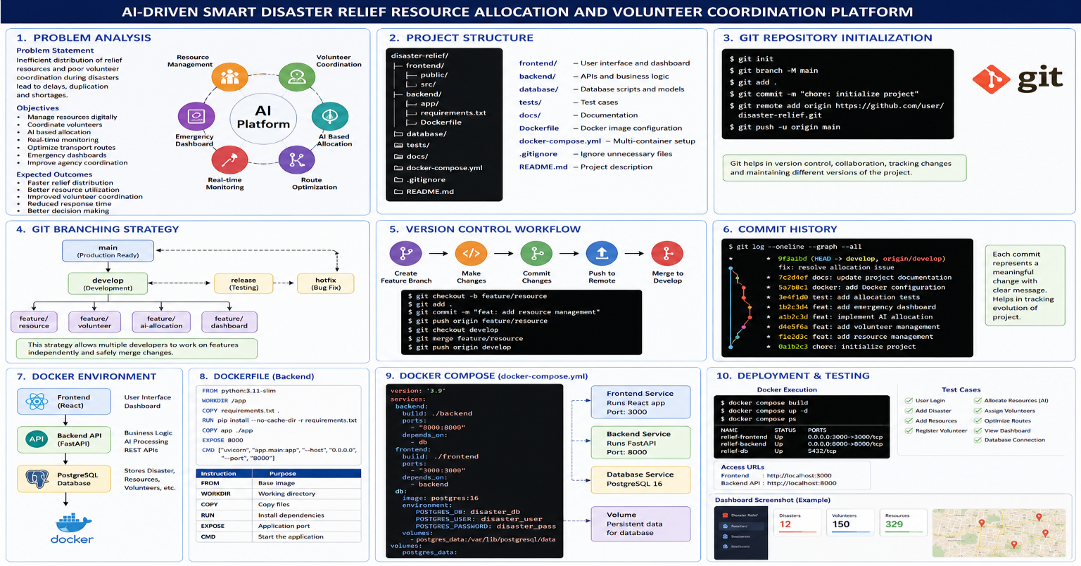

9. Docker Compose
services:
backend:
build: ./backend
ports:
- "8000:8000"
depends_on:
- db

frontend:
build: ./frontend
ports:
- "3000:3000"
depends_on:
- backend

db:
image: postgres:16
environment:
POSTGRES_DB: disaster_db
POSTGRES_USER: disaster_user
POSTGRES_PASSWORD: disaster_pass
volumes:
- postgres_data:/var/lib/postgresql/data

volumes:
postgres_data:
Services
- Frontend: User interface.
- Backend: APIs and AI processing.
- Database: Stores project data.
- Volume: Keeps database data persistent.

10. Deployment and Testing
Run:
docker compose build
docker compose up -d
docker compose ps
Test:
Frontend: http://localhost:3000
Backend: http://localhost:8000
Testing
- User login.
- Add disaster.
- Add resources.
- Register volunteer.
- Allocate resources.
- Assign volunteers.
- Check dashboard.
- Verify database connection.
Take screenshots of Git operations, Docker containers, API, and dashboard as evidence.

11. Benefits of Git and Docker
Git
- Collaboration.
- Version control.
- Branch management.
- Easy rollback.
- Change tracking.
Docker
- Portability.
- Consistent environment.
- Easy deployment.
- Dependency management.
- Scalability.

12. Challenges and Future Enhancements
Challenges
- Real-time disaster data.
- Network problems.
- AI accuracy.
- Data consistency.
- Security.
- Docker configuration.
Future Enhancements
- GIS and live maps.
- Mobile application.
- Weather API integration.
- IoT sensors.
- AI demand prediction.
- SMS alerts.
- Offline support.
- Cloud deployment.

13. Software Architecture
Three-Tier Architecture
Users
↓
Frontend / Dashboard
↓
Backend API
↓
AI + Business Logic
↓
PostgreSQL Database
Architecture Justification
Three-tier architecture provides:
- Clear separation of components.
- Easy maintenance.
- Better scalability.
- Improved security.
- Independent development of frontend and backend.

14. Conclusion
The proposed AI-driven disaster relief platform improves resource allocation, volunteer coordination, route planning, and emergency decision-making. Git provides effective version control, while Docker ensures portable and consistent deployment. The three-tier architecture makes the system modular, scalable, and maintainable.

